Website / Excel / Google Drive (docs & spreadsheets)
Stark Porter
(206) 276-1446
starkporter@gmail.com

Sign in sheet – Make sure everyone signs in and leaves their contact information.
- Build your own website:
  - www.weebly.com
If you are serious about building a website with www.weebly.com and need any assistance, contact me and I’ll help you any way I can. I’ve built about 7 websites on Weebly, they continue in improve their product every time I look.

- Excel
  - Practice being efficient (it saves you time, and time is $$)
    - Toggle between open programs and screens by using your; Left thumb on the Alt-key (keep Alt-key down), now, with your Left index finger, Tap the Tab-key once to see all the open screens. Continue to tap the tab key to go to a different screen.

  - Excel is smart – it will figure out your pattern and run with it.
    - Always start the pattern with two or three cells, so excel and figure it out.
    - Highlight those 2 or 3 cells.
    - Put your cursor in the bottom right corner of the last highlighted cell until you see the dark + sign.
    - Hold down the left mouse button and pull the + sign down or right (which ever way your pattern needs to continue to add to your pattern.
*** Excel is very smart, it can do a great deal with these patterns, practice. ***

  - Formulas make excel magical (date, sum, count, avg.)
    - The formula for today: =today() type this into a cell and hit return and it will show todays date.
    - Date and time: =now()
    - If you are interested in the formula I was using to determine a coaches years of service, give me a call. I have it now, but there are a few steps.
    - There are hundreds of formulas, google excel formulas and find what you need.

  - Text To Columns (under the data tab at the top of excel).
    - Choose delimited
    - You can separate by space (like we did between the first and last name)
    - … or you can separate by anything else
If you can do a fixed width separation (instead of delimited) also.
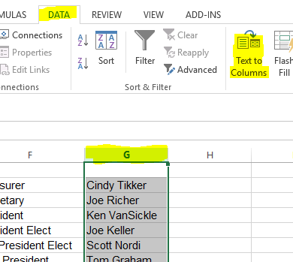
  - Combining 2 columns into 1
    - Start with the = sign.
    - then select the cell you want first,
    - then &,
    - then “, followed by whatever you want in-between the two cells with they combine into one cell
    - another “
    - another &
    - followed by the cell you want to combine with the first cell.
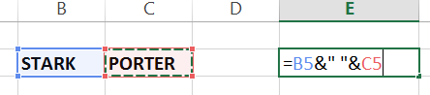
  - stripping a formula from a cell (so it is left with the value (or true text)
    - Highlight what you want to strip
    - Copy
    - Paste special (this is different than paste)
    - Select value
    - Select OK
    - Hit ESC at the top left of your keyboard.
  - Linking data to other parts of a worksheet or even different files.
    - Put the = sign in the cell you want the data to be copied to.
    - Go to the cell where the data is and click on it (once you click on the cell, a dashed border will move around the cell.
    - Hit <enter>
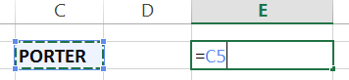

  - Build a great template, just update data within (PO Requisition Form / Annual Budgets worksheet, brackets, etc)
    - I have added samples documents: clock hour and summary sheet
- Google Drive, docs, spreadsheets, forms
  - If you do not have a google account, go to google.com and sign up for a free account. You will get a free 15Gigbytes of storage on their cloud (Google Drive). You will get unlimited storage if you store google documents on their cloud (google docs, google spreadsheet, google forms, etc)
  - Google spreadsheet is the equivalent of excel.
  - Benefits saving a google document to the google drive:
    - When you can give others permission to view, edit, your document.
    - You can publish a document and you are still able to edit.
    - You can embed document into a website, and still edit the document.
    - You can share a folder and all the documents inside the folder.
  - Departments, Leagues, Committees, etc. can keep all their documents in a shared folder and have access to the folder and documents inside.

- *** BONUS TIP YOU MAY NOT KNOW ABOUT ***
  - Texting from your computer (email).
You forgot your phone or you don’t have good phone coverage in the building, … or you just don’t want anyone to know you are texting.
    - You need to know 2 things: phone number & who their phones provider is (Verizon, T-mobile, sprint, etc).
    - Where you would type the email, put in the phone number, followed by the suffix that pertains to the service provider. (example: 2062761446@vtext.com this is how you would text me from your computer).
    - Here are the local more popular suffixes. Try it. Send yourself a text (or send me one – just leave your name so I know who is texting me).
      - Verizon – @vtext.com
      - AT&T – @txt.att.net
      - T mobile – @tmomail.net
      - Sprint – @messaging.sprintpcs.com

If you are not using a scheduling software program (WPA Network, etc), you need to know these three items above.

